**Properties and algorithms for Minimum Steiner Tree problem**

**Team :**

**Abhijit Bhupendra Singh U101116FCS002**

**Anirudh Sharma U101116FCS009**

**Aetukuri Srinath U101116FCS005**

**Ajay Sharma G S U101116FCS006**

**Ajinkya Bedekar U101116FCS183**

**Aman Garg U101116FCS281**

**INTRODUCTION**

**What is Steiner Tree?**

Steiner Minimal Trees

While a spanning tree spans all vertices of a given graph, a Steiner tree spans a given subset of vertices. In the Steiner minimal tree problem, the vertices are divided into two parts: ***Terminal*** and ***Non-Terminal Vertices***. The terminals are the given vertices which must be included in the solution. The cost of a Steiner tree is deﬁned as the total edge weight. A Steiner tree may contain some non terminal vertices to reduce the cost. Let V be a set of vertices. In general, we are given a set L ⊂ V of terminals and a metric deﬁning the distance between any two vertices in V. The objective is to ﬁnd a connected subgraph spanning all the terminals of minimal total cost. Since the distances are all nonnegative in a metric, the solution is a tree structure.

Given a graph and a **subset** of vertices in the graph, a steiner tree spans through the given subset. The Steiner Tree may contain some vertices which are not in given subset but are used to connect the vertices of subset.

**The Steiner Tree Problem** is to find the minimum cost Steiner Tree. See below for an example.

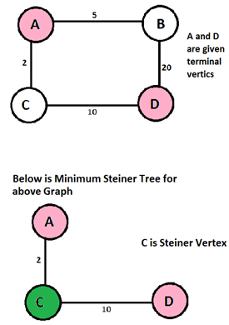

**Spanning Tree vs Steiner Tree**

Minimum Spanning Tree is a minimum weight tree that spans through **all** vertices.

If given subset (or terminal) vertices is equal to set of all vertices in Steiner Tree problem, then the problem becomes Minimum Spanning Tree problem. And if the given subset contains only two vertices, then it shortest path problem between two vertices.

Finding out Minimum Spanning Tree is polynomial time solvable, but Minimum Steiner Tree problem is NP Hard and related decision problem is NP-Complete.

Types of Steiner tree:

**1) Euclidean Steiner tree**

**2) Rectilinear minimum Steiner tree(RMST)**

**1)Euclidean Steiner tree** : The original problem was stated in the form that has become known as the Euclidean Steiner tree problem or geometric Steiner tree problem: Given N points in the plane, the goal is to connect them by lines of minimum total length in such a way that any two points may be interconnected by line segments either directly or via other points and line segments. It may be shown that the connecting line segments do not intersect each other except at the endpoints and form a tree, hence the name of the problem.

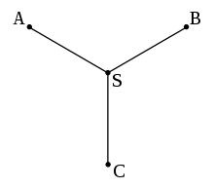 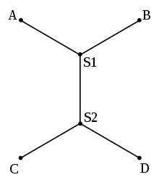

**2) Rectilinear minimum Steiner tree(RMST):**

The rectilinear Steiner tree problem is a variant of the geometric Steiner tree problem in the plane, in which the Euclidean distance is replaced with the rectilinear distance. The problem arises in the physical design of electronic design automation. In VLSI circuits, wire routing is carried out by wires that are often constrained by design rules to run only in vertical and horizontal directions, so the rectilinear Steiner tree problem can be used to model the routing of nets with more than two terminals.

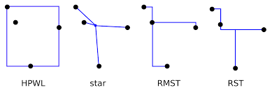

HPWL: half-perimeter wire length

Star

RMST: Rectilinear Minimum Steiner Tree

RST: Rectilinear Steiner Tree

**Steiner ratio:**

The Steiner ratio is the supremum of the ratio of the total length of the minimum spanning tree to the minimum Steiner tree for a set of points in the Euclidean plane. In the Euclidean Steiner tree problem, the Steiner ratio is conjectured to be 2/root(3) . Despite earlier claims of a proof, the conjecture is still open. In the rectilinear Steiner tree problem, the Steiner ratio is 3/2.

**PROPERTIES​ ​OF​ ​MINIMUM STEINER​ TREES**

* Given a graph and a subset of vertices in the graph, a​ ​Steiner​ ​tree​ ​spans​ ​through​ ​the​ ​given​ ​subset.
* The Steiner Tree may contain some vertices, which are not in given subset but connects the vertices​ ​of​ ​subset.
* The Steiner Tree Problem is to find the minimum cost​ ​Steiner​ ​Tree.
* If given subset (or terminal) vertices is equal to set of all vertices in Steiner Tree problem, then the problem becomes Minimum Spanning Tree problem.
* If the given subset contains only two vertices, then​ ​it is​ ​shortest​ ​path​ ​problem​ ​between​ ​two​ ​vertices.
* Minimum​ ​Steiner​ ​Tree​ ​problem​ ​is​ ​NP​ ​Hard.
* There are exactly​ ​three​ ​edges​ ​at​ ​every​ ​Steiner​ ​vertex.
* The angles between the edges meeting at a Steiner vertex​ ​is​ ​120​ ​degrees.
* If there are N vertices then we can use a maximum of​ ​N-2​ ​Steiner​ ​vertices.

LITERATURE SURVEY

The “Steiner problem” is named after the Swiss mathematician Jacob Steiner (1796-1863), who solved and popularized the problem of joining three villages by a system of roads having minimum total length (he also addressed the general case of this problem, and made many fundamental contributions to projective geometry).

The following is the list of various researchers who tried to solve Steiner minimal tree (SMT) problem and improve its complexity.

* In 1966 Hanan showed that for a pointset P there exists an SMT whose Steiner points S are all chosen from the Hannan grid, namely the intersections of all the horizontal and vertical lines passing through every point of P (see Figure Below).

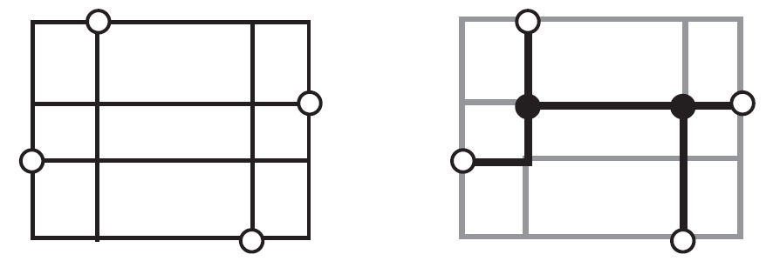

Figure : Hanan’s theorem: there exists an SMT with Steiner points chosen from the Hanan grid, i.e., intersection points of all horizontal and vertical lines drawn through the points.[1]

* In 1977 Garey and Johnson proved that making Steiner points to lie on the Hanan grid will not change the property of rectilinear SMT problem to be NP-complete .
* In 1976, Hwang showed that the MST over P is a good approximation to the SMT, having performance ratio ≤ 3/2 for any pointset P in the rectilinear plane.
* In 1992 Zelikovsky developed a rectilinear Steiner tree algorithm with a performance ratio of 11/8 times optimal.

**EXACT ALGORITHMS**

As Steiner Minimum Tree is NP-hard problem.It can’t be solved in polynomial time.So, Many scientists have worked on it and proved exact algorithms having different complexities.

**Dreyfus & Wagner Theorem:-**

“Edge weighted Steiner Tree can be solved in time

O(3t n + 2t n^2 + n(n log n + m)).”

Improvements of the D-W Algorithm

* The 1971 D-W algorithm achieves time

O(3t n + 2t n2 + n(n log n + m)) This

can be improved to O(3t n + 2t (n log n

+ m)) by computing the distances more

cleverly on demand[Erickson, Monma,

Veinott Mathematics of Operations

Research 1987]

* In 2007 Fuchs, Kern, and Wang [Math. Meth. Oper. Res.] improved this to O(2.684t n^O(1)) and
* Molle, Richter, and Rossmanith [STACS 2006] improved this to O ((2 + δ) k ))[2]

Exponential Time Algorithms

* The fast exponential algorithms are obtained by combining branching for large values of t and FPT

algorithms for small t.

* The fastest for weighted case is based on the algorithm of Molle achieving O(1.42n) in exponential space
* The only paper devoted to such algorithms is by Fomin, Grandoni,Kratsch, Lokshtanov, Saurabh

[Algorithmica 2009 / ESA 2008]

* It uses more involved branching, quasi FPT algorithm, and analyses the running time by Measure & Conquer.
* It is polynomial space and originally achieved running time O(1.59n) for the weighted case and O(1.55n) for the cardinality case.
* Plugging in the O(2t ) algorithm of Nederlof, the running time can be improved to O(1.36n) for the

cardinality case.[3]

The Iterated 1-Steiner (I1S) Approach

One of the earliest and most effective Steiner tree approximation schemes to break away from the herd of MST-improvement schemes is the Iterated 1-Steiner (I1S) approach of Kahng and Robins.The I1S heuristic is simple, easy to implement, generalizes naturally to any dimension and metric (including arbitrary weighted graphs), and significantly outperforms previous approaches, as detailed below. The I1S algorithm was subsequently proven to be the earliest published Steiner approximation method to have a non-trivial performance ratio (of 1.5 times optimal) in quasi-bipartite graphs.[4]

We are planning to study and implement the following algorithms:-

* DREYFUS AND WAGNER Algorithm of complexity O(3^k)
* Improvisation of above algorithm to O(2.684^k) and O ((2 + δ) ^k )
* We’ll convert a graph into sub graph and make it a minimum spanning tree problem and implement it.

Contributions:

Anirudh Sharma - Introduction

Abhijit Singh - Types of steiner tree and

Steiner Ratio

Ajinkya - Properties

Ajay Sharma - Literature Survey

Srinath - Exponential time

algorithms

Aman Garg - Iterated 1s approach

REFERENCES:

[1] Gabriel Robins and Alexander Zelikovsky, Minimum Steiner Tree Construction

[2]Ondra Suchy,Exact Algorithms for Steiner Tree

[3] G. Robins and A. Zelikovsky. Improved steiner tree approximation in graphs, January 2000

[4] A. B. Kahng and G. Robins. A new family of steiner tree pages 428–431, Santa Clara, CA, November 1990